

**1Medify**

**Software Requirements Specification**



**Internship Program 2022**

# **Version Control**

|  |  |  |  |
| --- | --- | --- | --- |
| Date | Version | Author | Description of Changes |
| 12/04/2022 | V.0.3 | Neha Dubey | Created Software Requirements Specification, Document |

# **Table of Contents**

Version Control 2

1. Introduction 4

1.1 Purpose 4

2. Registration Page 5

2.1 Register as Pharmacy store 5

2.2 OTP Verification for the users 7

2.3 Register as Doctor 8

2.4 Register as a Patient 11

3. Login 13

3.1 Forget Password 14

4. Profile Page 16

4.1 Pharmacist’s Profile Page 16

4.2 Doctor’s Profile Page 17

4.3 Patient’s Profile Page 18

5 Doctor’s “My Document” Page 19

5.1 Create New Prescription 20

5.2 Search Prescription 21

5.3 Prescription Approval Request 23

5.4 List of Pharmacy Stores 24

6 Pharmacist’s “My Document” Page 25

6.1 Prescription Sent to Doctor 25

6.2 Prescription Status 26

6.3 Print Approved Prescription 27

6.4 List of Doctors 28

7 Patient’s “My Document” Page 29

7.1 Prescription Sent to Doctor 30

7.2 Download and Print Prescription 31

8 Notification Interfaces 32

Assumptions 33

Dependencies 33

# **Introduction**

As a Doctor, Pharmacist, and Patient, the user should be able to access the system. Pharmacist and Patient can search patient’s medical prescriptions and can send it to the doctor for their approval. Doctor can create prescriptions and add into the system, and the user (Pharmacists, Patients) can print approved prescriptions.

* In the system, there will be a list of doctors, a list of the patients, and a list of the pharmacy store.
* Doctor can create and add the prescription into the system.
* Doctor can write and upload prescription into the system.
* Prescription acceptance time will be 10 minutes for each doctor, after 10 minutes if the doctor does not take any relevant actions (Accept, Reject, Busy), then it will be sent to another doctor for their approval.
* If the doctor is busy, then doctor can click on busy button, and the prescription will automatically send to another doctor.
* Patients and pharmacists can upload and send prescription for doctors’ approval.
* System will send prescriptions from one doctor to another doctor on the priority list: In 1 to 10 loops.
* Prescription uploaded by doctor will sync with the database of Pharmacist and Patient.

## **1.1 Purpose**

* The main purpose of the 1Medify system will be to use minimal paper. Patient doesn’t have to carry prescription.
* It can be created, uploaded, or searched and viewed if they are existing patient of 1Medify system.

**Main Screen of The Users (Pharmacists, Doctors, Patients)**

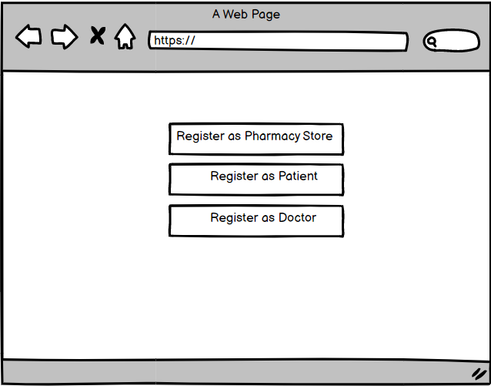

# **Registration Page**

## **Register as Pharmacy store**

* The pharmacy’s module will allow a pharmacist to login to the system with their credentials.
* In case, the patient is not able to send the prescription, then pharmacist will upload and send prescription to doctor for their approval.
* System is designed to sync with database of doctor’s module.
* The pharmacist will be able to view and search patient’s previous list of prescription if any diagnoses were performed earlier.
* 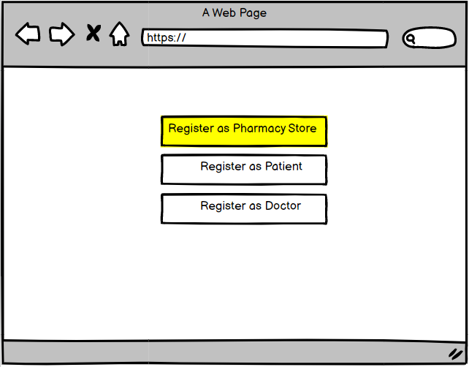Pharmacist will get notification if a doctor will approve or reject the prescription.

**Enter Basic details of Pharmacist**

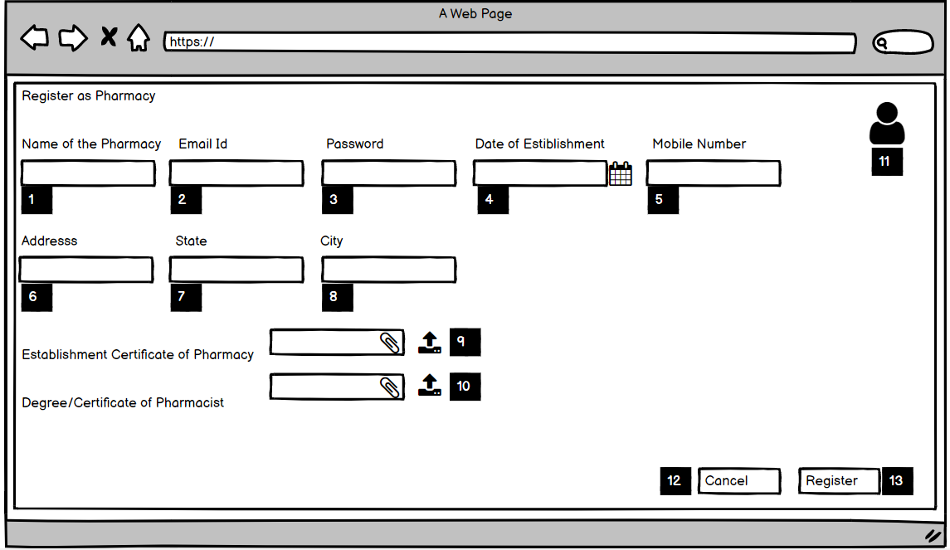

**Acceptance Criteria**

1. The Pharmacist needs to provide the name of pharmacy store.
2. The Pharmacist needs to provide an email address.
3. The Pharmacist needs to provide a password.
4. The Pharmacist needs to provide the date of establishment.
5. The Pharmacist needs to provide a mobile number.
6. The Pharmacist needs to provide the address of the pharmacy store.
7. The Pharmacist needs to provide name of the state.
8. The Pharmacist needs to provide a city name.
9. The Pharmacist needs to upload the establishment certificate of the pharmacy store.
10. The Pharmacist needs to upload a certificate the pharmacist.
11. The Pharmacist needs to upload a profile picture and picture size should be 500 KB.
12. Cancel

* The Pharmacist will click on the cancel button.
* Registration will be cancelled.
* The Pharmacist will redirect to the registration page.

1. Registration

* Click on the Register button.
* The Pharmacist will get this “Registration successful!” Message.

**Validation:**

1. Email id must be valid and should be in this format ‘ [xyz123@gmail.com](mailto:xyz123@gmail.com)’.
2. Password must be at least 8 characters, 1 number, 1 uppercase letter, lowercase letter, one special character.”
3. Mobile Number must be in this format +91 XXXX-XX-XXXX.
4. Uploaded certificate must be an original photocopy.

## **2.2 OTP Verification for the users**

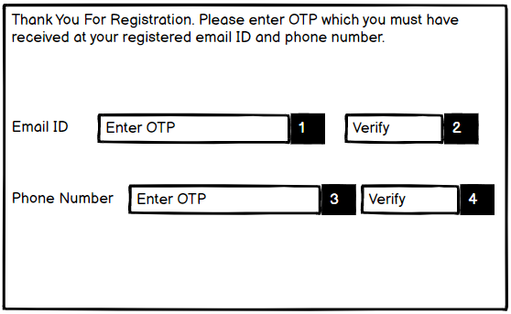

**Resend**

**User:** Patients, Pharmacists, Doctors

**Acceptance Criteria**

1. The user will receive OTP on the registered email ID.
2. The user will verify by entering the 4-digits OTP number.
3. The user will receive OTP on the registered mobile number.
4. The user will verify by entering 4-digit OTP number.
5. The user will resend OTP if OTP has expired.

And then user will be redirected to the Home Screen.

**Validation:**

1. OTP must be sent on registered email ID and mobile number.
2. OTP must be a 4-digits number.
3. OTP must be valid only for 1 minute.

## **Register as Doctor**

* Doctor’s module will allow doctors to login into the system with their credentials.
* Doctor can create prescription and add it into the system.
* Doctor can write and upload prescription into the system.
* Prescription uploaded by doctor will sync with the database of pharmacist and Patient.
* The system will allow doctors to create, search, verify, view, reject and accept prescription as well as view the profile of pharmacist. Simultaneously, uploading prescription when the diagnosis is performed.
* The prescription would be sent to doctor for verification and it would be upon doctor to approve or reject.
* Doctor will get notification if pharmacist or patient will send prescription for approval.
* If doctor is busy, doctor can click on busy button then prescription will be automatically sent to another doctor.

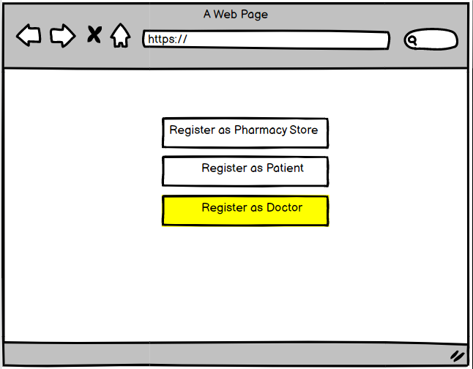

**Enter basic details of doctor**

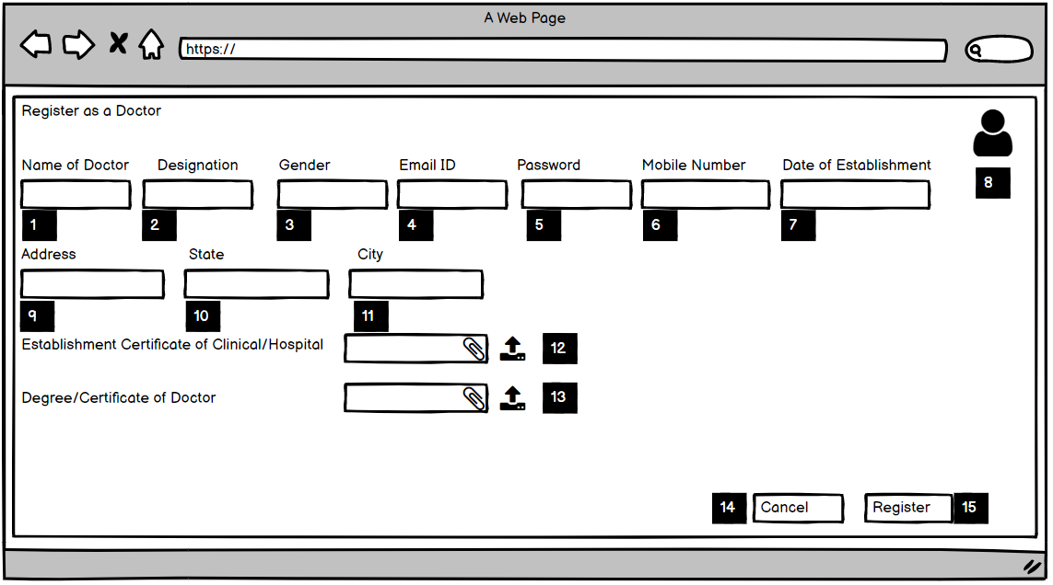

**Acceptance Criteria**

1. The Doctor needs to provide their name.
2. The Doctor needs to provide a designation.
3. The Doctor needs to provide gender male/female.
4. The Doctor needs to provide an email address.
5. The Doctor needs to provide a password.
6. The Doctor needs to provide a mobile number.
7. The Doctor needs to provide the date of establishment.
8. The Doctor needs to upload a profile picture.
9. The Doctor needs to provide the address of the doctor.
10. The Doctor needs to provide a state name.
11. The Doctor needs to provide the city name.
12. The Doctor needs to upload the establishment certificate of the doctor.
13. The Doctor needs to upload a doctor certificate.
14. Cancel

* The Doctor will click on the cancel button.
* Registration will be cancelled.
* The Doctor will redirect to the registration page.

1. Registration

* Click on the Register button.
* The doctor will get this “Registration successful!” Message.

**Validation:**

1. Email id must be valid and should be in this format ‘ [xyz123@gmail.com](mailto:xyz123@gmail.com)’.
2. Password must be at least 8 characters, 1 number, 1 uppercase letter, lowercase letter, and one special character.
3. Mobile Number Must be in format +91 XXXX-XX-XXXX.
4. Uploaded Certificate must be an original photocopy.

## **Register as a Patient**

* As a Patient, I will create a login credential and will have to enter basic details.
* Patient will click on “My Document” user can view, search, upload, and send prescription to doctor for their approval.
* Patient can view, download, and print approved prescription.
* Patient will get notification if any action (reject, accept) is taken by doctor.

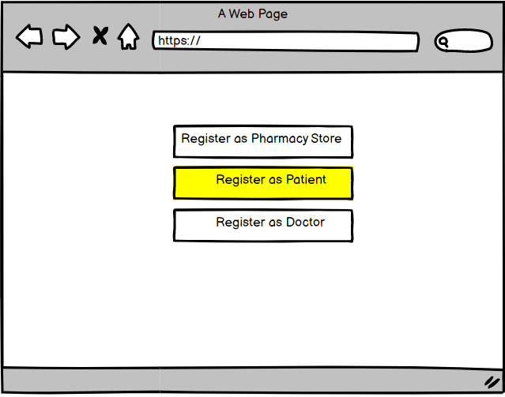

**Enter basic details of patient**

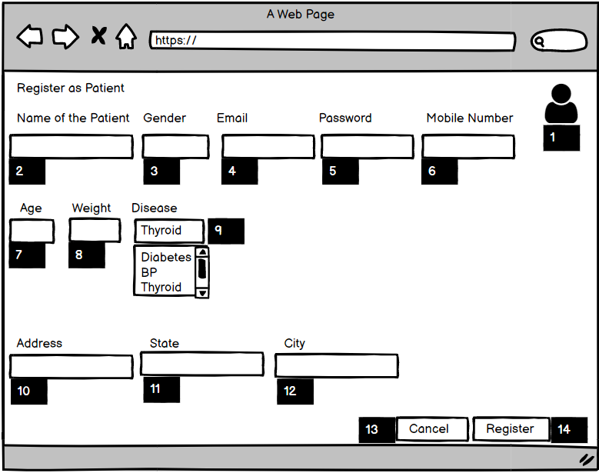

**Acceptance Criteria**

1. The Patient will be able to the enter their name.
2. The Patient will be able to the enter gender (male/female).
3. The Patient will be able to provide an email address.
4. The Patient will be able to provide a password.
5. The Patient needs to provide a mobile number.
6. The Patient needs to enter their age, weight, and disease.
7. The Patient needs to upload a profile picture.
8. The Patient needs to provide the address.
9. The Patient needs to provide state name.
10. The Patient needs to provide city name.
11. Cancel

* The Patient will click on the cancel button.
* Registration will be cancelled.
* The Patient will redirect to the registration page.

1. Registration
   * Click on the Register button.
   * The Pharmacy will get this “Registration successful!” Message.

**Validation:**

1. Email id must be valid and should be in this format ‘ [xyz123@gmail.com](mailto:xyz123@gmail.com)’.
2. Password must be at least 8 characters, 1 number, 1 uppercase letter, lowercase letter, and one special character.
3. Mobile Number Must be in format +91 XXXX-XX-XXXX.

# **Login**

As a registered user (Patients, Doctors, Pharmacists), I will login but as a new user first I will register and then move to the login page, Login Screen will be same for all the users (Patients, Doctors, Pharmacists).

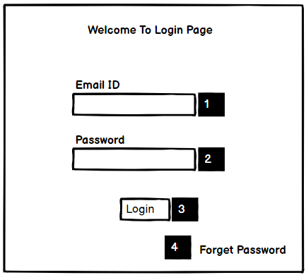

**User:** Patients, Pharmacists, Doctors

**Acceptance Criteria:**

1. The user needs to provide a registered email ID.
2. The user needs to provide a password.
3. The user will click on the login button.

**Validation**

1. Email id must be registered.
2. Password must be matched to registered password.

## **3.1 Forget Password**

If the user(Patients, Pharmacists, Doctors) forgets the password, click on the “forgot password” link.

**Acceptance Criteria:**

1. Reset your password

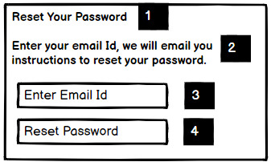

**User:** Patients, Pharmacists, Doctors

1. Enter your email id and we will email you instructions to reset your password.
2. The user will enter registered email id.
3. The user will click for reset password.

* Email sent to user with password reset link.

1. Message Sent

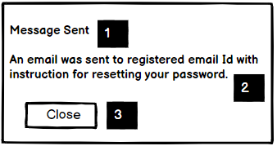

2. An email was sent to [xyz@gmail.com](mailto:xyz@gmail.com) with instructions for reset your password.

3. Click on the close button.

1. Reset password

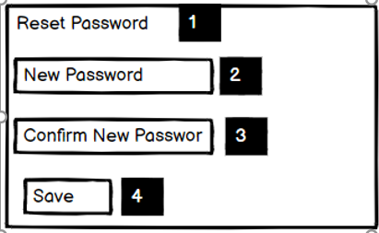

2. The user will create new password.

3. The user will confirm the new password.

4. The user will click on the Save button.

1**.** Password Reset.

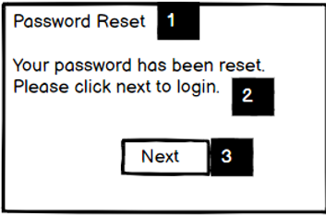

2. The user will get this message Your password has been reset successfully.

3. The user will click on the ‘Next’ button to login.

**Validation**

1. Email id must be registered.
2. Password must match the re-entered password.
3. Password must be at least 7 characters, 1 number, 1 uppercase letter, lowercase letter, and one special character.

# **Profile Page**

In the profile section, there will be profile page of users (Patients, Pharmacists, Doctors) with full details.

## **4.1 Pharmacist’s Profile Page**

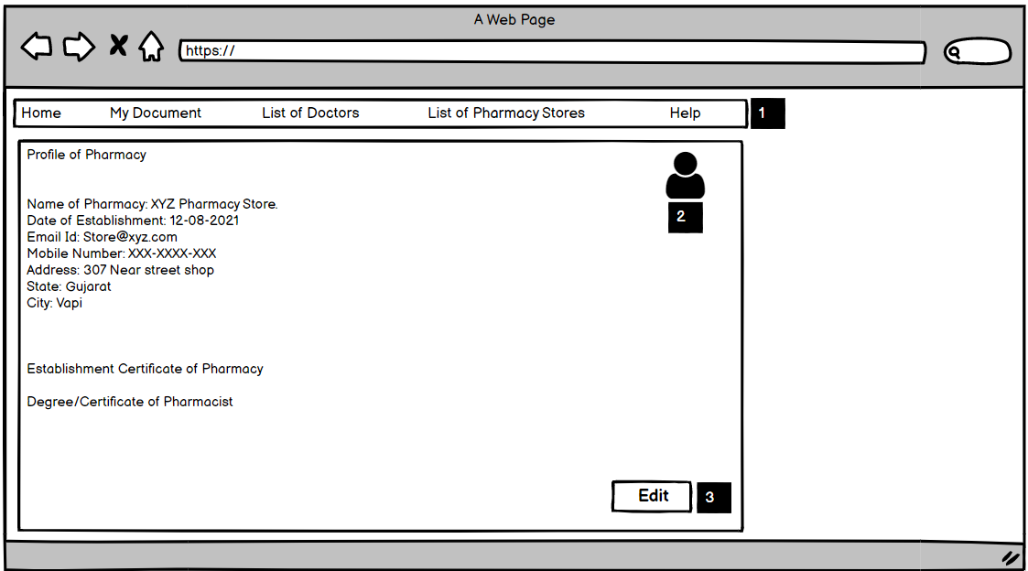

**Acceptance Criteria:**

1. There will be home page.
2. There will be ‘My document’ option where the pharmacist will be able to view prescription if it is approved, and can print prescription.
3. There will be ‘List of Doctor’ and pharmacist can view doctor’s profile.
4. There will be pharmacist’s profile information like name, date of establishment, phone number, address, and certificates.
5. The pharmacist can upload profile picture.

**Edit**

1. Click on the edit button, and the pharmacist will have the ability to view and update personal details.
2. The pharmacist can edit the name, email id, password, mobile number, address.

**Validation**

1. Pharmacist can upload 500 KB PNG profile picture.
2. Email id and password must be registered.
3. Uploaded certificate must be an original photocopy**.**

## **4.2 Doctor’s Profile Page**

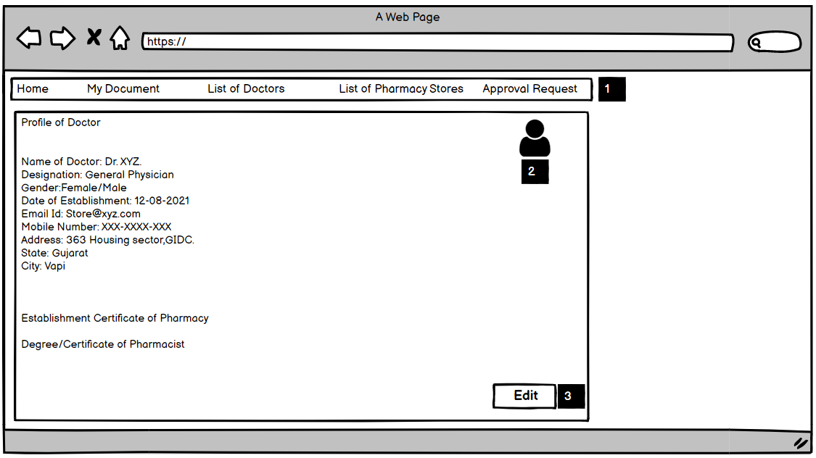

**Acceptance Criteria:**

1. There will be basic information like name, designation, gender, date of establishment, email id, mobile number, address, and certificate.
2. The doctor can upload profile picture.

**Edit**

1. Click on the edit button, the doctor will have the ability to view and update personal details.
2. The doctor can edit the name, email id, password, mobile number, and address, and profile picture.

**Validation:**

1. Doctor can upload 500 KB PNG profile picture.
2. Date of the establishment must be correct.
3. Email id and password must be registered.
4. Uploaded certificate must be an original photocopy.

## **4.3 Patient’s Profile Page**

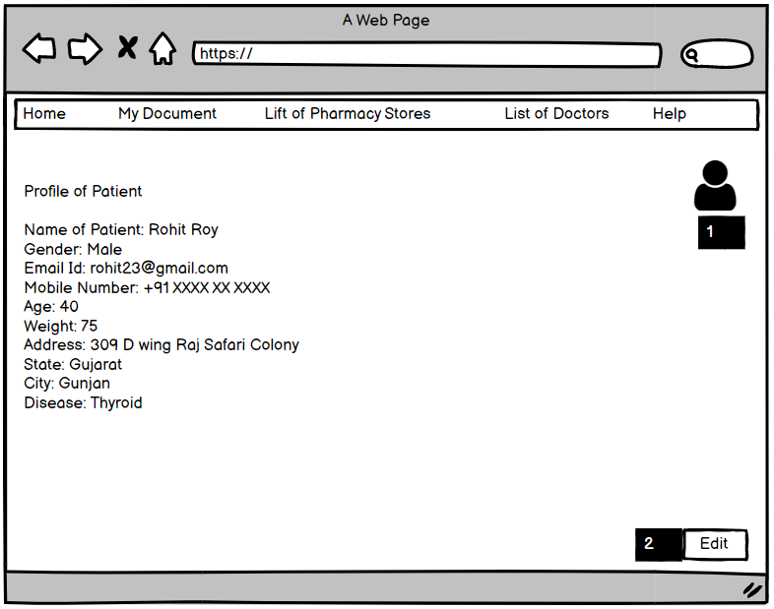

**Acceptance Criteria:**

1. There will be basic information like name, designation, gender, date of establishment, email id, mobile number, address, and certificate.
2. The Patient can upload profile picture.

**Edit**

1. Click on the edit button, and the patient will have the ability to view and update personal details.
2. The Patient can edit the name, email id, password, mobile number, address, and profile picture.

**Validation:**

1. Pharmacist can upload 500 KB PNG. Profile picture.
2. Email id and password must be registered.

# **5 Doctor’s “My Document” Page**

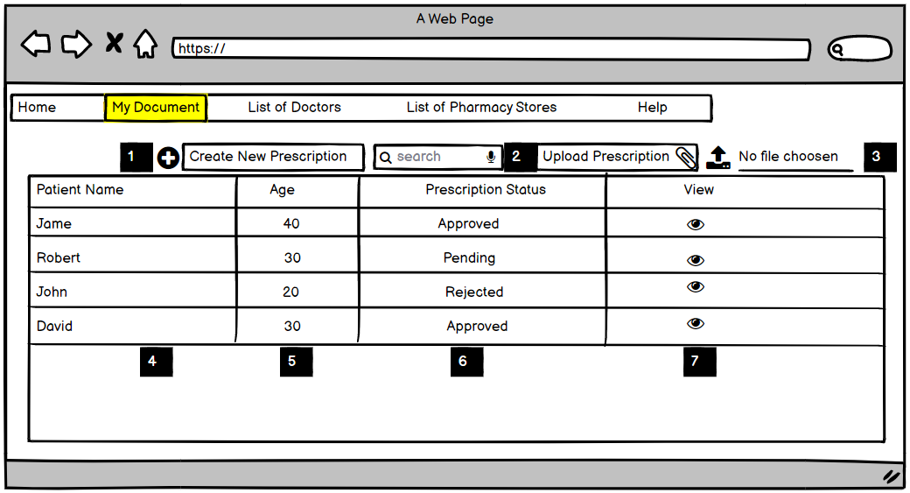

The system will allow doctor to create, upload, view prescriptions and can search patients’ medical prescriptions.

Doctor can upload written prescription in PNG or PDF format.

Doctor will have ability to create prescription and add into the system. Pharmacist and patient both can send prescription to doctor for their approval. The status of the prescriptions created by the doctor will be automatically set to ‘Approved’.

**Acceptance Criteria:**

Doctor will click on ‘My document’ and can view, search and upload prescriptions.

1. Click on create new prescription, the system will allow doctor to create prescription and add into the system.
2. The doctor can search prescription.
3. The doctor will attach and upload prescription in Pdf, PNG format.
4. There will be patient’s name.
5. There will be patient’s age.
6. There will be the status of prescription: pending, approved, rejected.
7. There will be view icon, and it will show the viewers.

**Validation:**

1. Only the doctor can create prescription.
2. Prescription must be in Pdf, PNG.
3. Prescription must be 1MB.

## **5.1 Create New Prescription**

**Acceptance Criteria:**

1. The doctor will click on create new prescription option and will create the prescription.

* The doctor will write prescrition’s detail: hospital’s name, doctor’s name, mobile number, patient’s name, patient’s age, gender, address, and date.

1. The doctor will upload created prescription into the system, prescription uploaded by doctor will sync with the database of the Pharmacist and Patient.

**Validation:**

1. Only the doctor can create prescription.
2. The patient’s details must be valid.
3. Prescription date must be valid with complete information.

## **5.2 Search Prescription**

Search Previous Approved Prescription

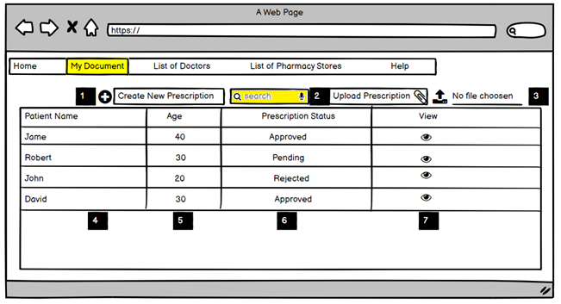

* The doctor can view previously approved prescription.
* The doctor will enter the name of patient “Mohit Roy” list of approved prescription will be displayed.

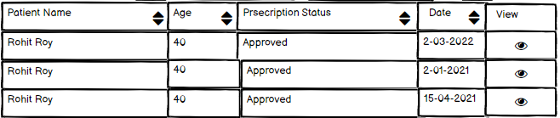

By clicking on a particular patient name field, all previous prescription will be opened and doctor can create a new prescription for an existing patient.

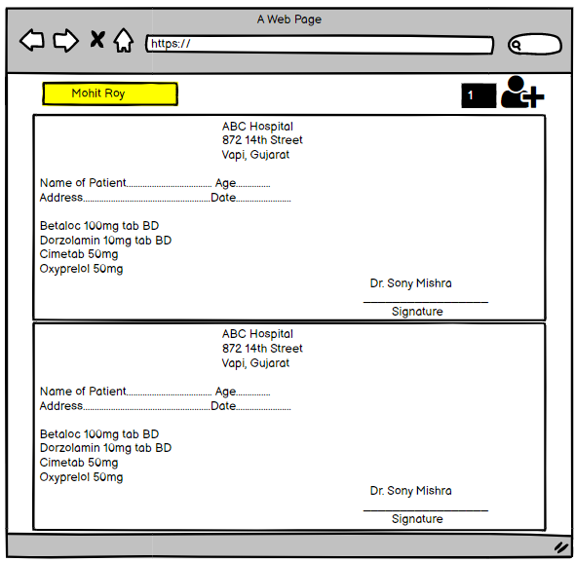

## **5.3 Prescription Approval Request**

* After successful registration, the system will allow the doctor to view the list of prescriptions sent by the pharmacy store or patient.

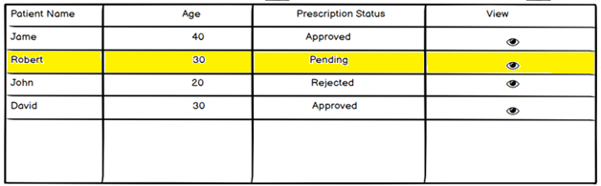

* In the prescription, there will be the hospital name, patient’s name, disease, age, and address.
* The doctor will have the ability to approve/reject prescriptions sent by the pharmacy store.
* The doctor can reject the prescription if there will be incomplete information like disease, age, name, valid date, in prescription and also can reject an expired prescription.
* The doctor will approve the prescription if it will be valid with full information and a valid date.
* There will be three statuses pending, request, and reject.

1. **Rejected:** This status will show that the prescription has been rejected by the Doctor.
2. **Approved:** This status will show that the prescription has been approved by the Doctor. Pharmacy stores can print approved prescriptions.
3. **Pending:**  This status will show that the doctor has not seen the prescription yet and the prescription is waiting for the Doctor’s approval.
4. **Busy:** In case, the doctor is busy, click on busy button. Prescription will automatically send to the next doctor.

* The application will allow doctors to view the list of prescriptions.
* The doctor can click on any prescription from the list and can view the prescription details.
* If the prescription is pending, the doctor will take relevant actions (reject or approve).

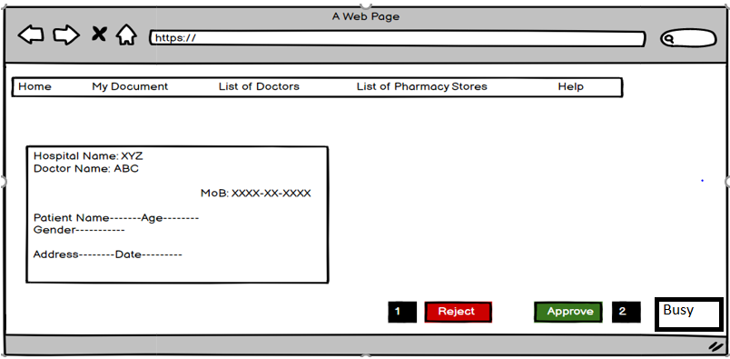

## **5.4 List of Pharmacy Store**

There will be list of registered pharmacies.

**Acceptance Criteria:**

1. The doctor will click on list of pharmacy store, and displayed list of all registered pharmacy store, the doctor will click on particular name.
2. Basic details of pharmacy store will be displayed.

**Validation:**

1. The user can not view password of pharmacy’s profile

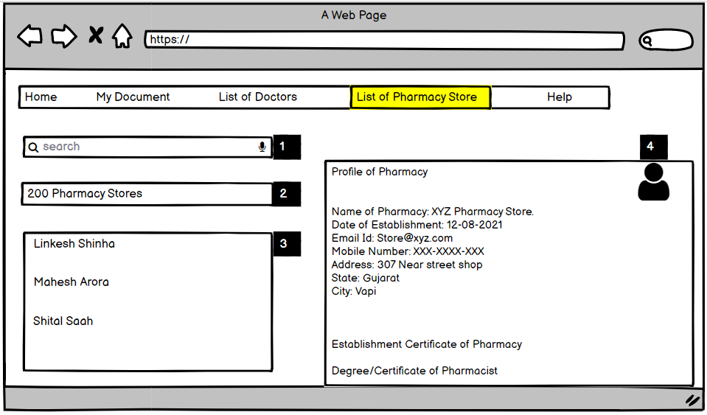

# **Pharmacist’s “My Document” Page**

## **6.1 Prescription Sent to Doctor**

Prescription sent by pharmacy store to doctor for approval

-

**Acceptance Criteria:**

1. The pharmacist will attach and upload prescription in Pdf, PNG format.
2. The pharmacist will search prescription.
3. The pharmacist will “Send prescription to doctor for their approval”.
4. The pharmacist can print prescription.

**Validation:**

1. Prescription must be in Pdf, PNG.
2. Prescription must be 1MB.

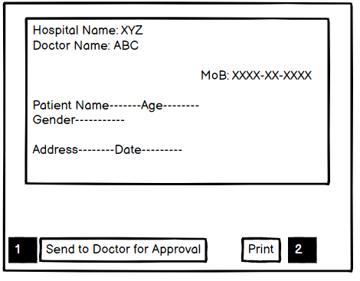

## **6.2 Prescription Status**

**Acceptance Criteria:**

* The pharmacy store will send prescription to doctor for their approval.
* There will be three statuses pending, request, and reject.

1. **Rejected:** This status will show that the prescription has been rejected by the Doctor.
2. **Approved:** This status will show that the prescription has been approved by the Doctor. Pharmacy stores can print approved prescriptions.
3. 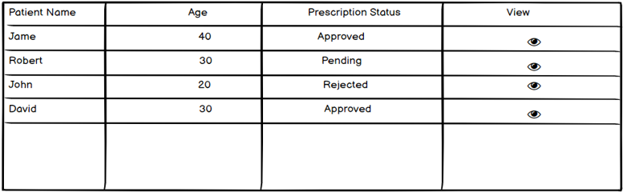**Pending:** This status will show that the doctor has not seen the prescription yet and the prescription is waiting for the Doctor’s approval.

**Validation:**

1. The pharmacist can print approved prescription.

## **6.3 Print Approved Prescription**

1. 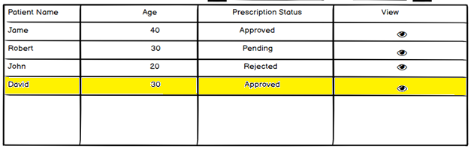The pharmacist will select approved prescription in list of prescription.
2. The pharmacist can view details of prescription.
3. The pharmacist can print approved prescription.

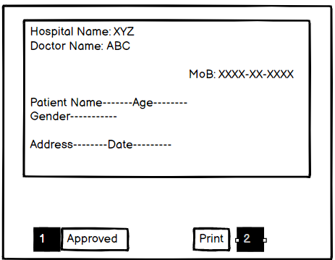

## **6.4 List of Doctors**

There will be list of registered doctors, the pharmacist will click on ‘list of doctors’ and displayed page of doctor with full details.

**Acceptance Criteria**

1. The pharmacist will click on list of doctors, and displayed list of all registered doctors, click on particular name.
2. Basic details of doctors will be displayed.

**Validation:**

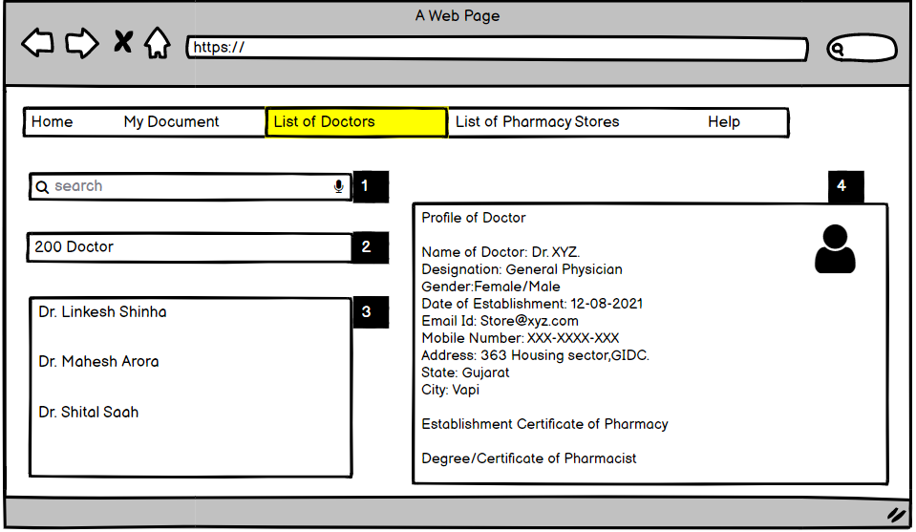

# **Patient’s “My Document” Page**

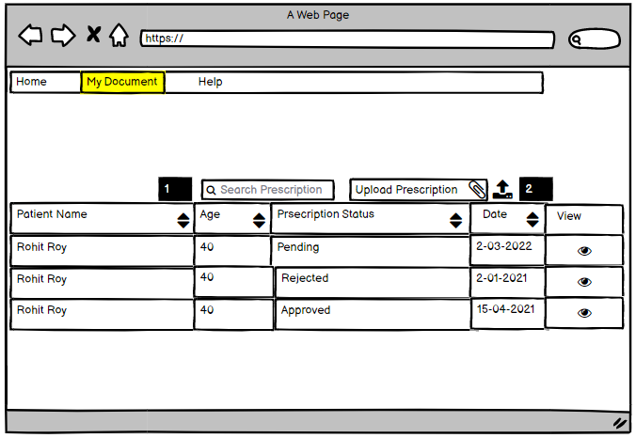

**Acceptance Criteria:**

Patient will click on ‘My document’ and can view, search, upload and send prescription to doctor for their approval and patient must be able to download and print the approved prescription.

1. The patient can search prescription.
2. The patient will attach and upload prescription in Pdf, PNG format.
3. There will be patient’s name.
4. There will be patient’s ages.
5. There will be status of prescription: pending, approved, rejected.

* **Rejected:** This status will show that the prescription has been rejected by the Doctor.
* **Approved:** This status will show that the prescription has been approved by the Doctor. User can print approved prescriptions.
* **Pending:**  This status will show that the doctor has not seen the prescription yet and the prescription is waiting for the Doctor’s approval.

1. There will be view icon.

**Validation:**

1. Prescription size must be 1MB.

## **7.1 Prescription Sent to Doctor**

**Acceptance Criteria:**

1. The patient will select “my document”.
2. The patient will search prescription, and list of prescription will be displayed.
3. The patient will “Send Prescrption to Doctor for their Approval”.



## **7.2 Download and Print Prescription**

The Patient will have the ability to view, download, and print approved Prescription.

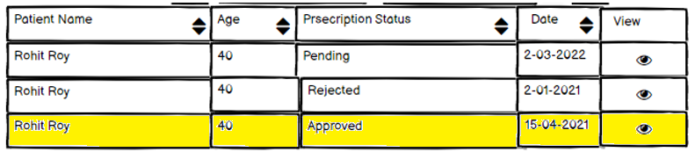

* The patient will click on the approved prescription, and then the prescription page will be displayed.
* The patient will have the ability to view, download and print approved prescription.

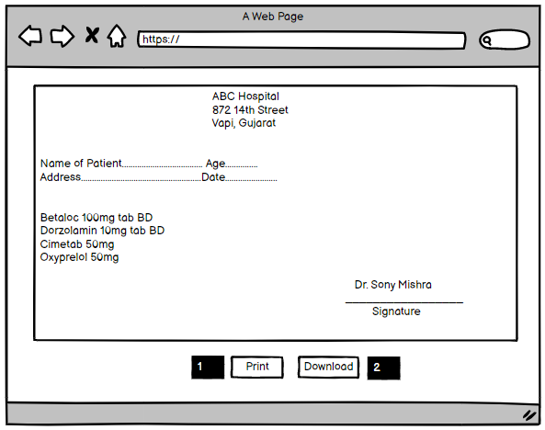

# **8 Notification Interfaces**

(User: Patients, Doctors, Pharmacists)

* This web application will need system-generated e-mail notifications.
* With the help of this, the users will get notified.
* There will be different kinds of auto-generated email notifications to different kind of users in different scenarios.
* System-generated email notifications for **Doctor**:

1. When a Pharmacist sends prescription for approval.

* Notification Message: “Pharmacy store (Medicare Pharmacy) has sent prescription for approval.”

1. When a Patient sends prescription for approval.

* Notification Message: “Patient Name (Rohit Roy) has sent prescription for approval.”
* System-generated email notifications for **Pharmacist**:

1. When Doctor will create a new prescription.
   * + Notification Message: “New prescription has been uploaded”
2. When Doctor will approve/reject the prescription.
   * + Notification Message: “Prescription has been accepted”.
     + Notification Message: “Prescription has been rejected”.

* System-generated email notifications for **Patient**:

1. When Doctor will create a new prescription.

* Notification Message: “New prescription has been uploaded”

1. When Doctor will approve/reject the prescription.

* Notification Message: “Prescription has been accepted”.
* Notification Message: “Prescription has been rejected”.

1. When Pharmacist sends prescription to Doctor for their approval.

* Notification Message: “Pharmacy store (Medicare Pharmacy) has sent prescription for approval.”

# **Assumptions**

* There will be ‘list of doctors’ and a list of pharmacy store’ so that they can view profile and information with each other.
* If prescription is not added into the system, the doctor will have to create template for new prescription creation and add-in system.

# **Dependencies**

* Only doctors and pharmacy can use this system.
* Without internet, user can’t access this system.